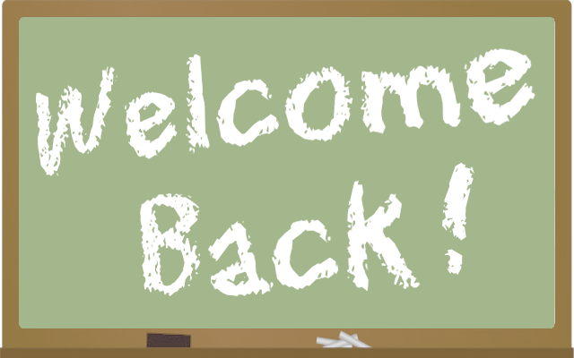 September 21, 2015
Welcome to Division 3. I look forward to spending the rest of the year learning and working with your child this school year. I hope the information included in this letter will help you to understand the expectations of your child while in grade 6. We are striving to develop a positive attitude about school and about learning. Establishing good work habits and routines is the main focus in the classroom at the beginning of the school year. Our class will be talking a lot about what it means to be a Panorama Park student as well as a member of division 3.

A Little Bit About Me

I have worked with the Surrey School District for the past several years primarily in the intermediate grades. I enjoy teaching and working with children. During my free time I enjoy taking art classes and paint. I also like to try out different recipes and blog about fashion when I have the time. In the winter, I like to snowboard as much as possible or take advantage of the many great local restaurants.

Lunch and Recess Snacks

A vital part of learning readiness is to be rested and well fed. Please ensure that your child has a nutritious breakfast every morning and that they come to school with a healthy lunch. Breakfast to lunch is a long time to go without food, so please include a healthy snack for your child for recess. Learning improves if children eat healthy food while at school. For optimal learning I encourage you to avoid sending pop, chips, chocolate bars or candy as lunch food. We will be talking about this in class as we learn about nutrition.
The best drink for your child at school is water. It refreshes and hydrates them without causing the sugar high and low that can happen even with all natural juices. Please provide a water bottle full of fresh water each day. Students are encouraged to have this at their desk to drink all day.

Attendance

Regular attendance and being on time for school is extremely important for your child’s progress. If your child is going to be absent, please call the school to let us know. If your child is late, they will need to check in at the office to receive a late slip. We do appreciate it if you keep children with colds, fevers or other contagious diseases at home.

French
This year we will be having French lessons twice a week. Please be enthusiastic and encourage your child with their French homework and projects, as for many of them it will be a new learning opportunity
Planners and Homework

We will be using planners to organize ourselves this year. The school planner is the most important tool your child has to build success. Using a planner is a very important life skill. Your child will have regular homework. Your consistent effort now could well mean good homework habits for the rest of their school career. Planners are also a way of communicating between home and school. We will not only use them to manage homework, but also to provide reminders about school activities and events. Please feel free to include family events such as birthdays, trips and scheduled weekly events on the pages. Also, feel free to write a note to your child or me at any time.
Homework is:
- Read every night for 20 - 30 minutes from Mon. to Fri. – reading logs provided by the library
- Weekly spelling unit work – due every Thursday as well as weekly spelling test every Friday.
- Other assignments as necessary
Make homework a priority.
Each evening the students should refer to their planners to do their homework. There is a message every day. If there is no message, your child did not write down the homework. I encourage you to return to the school to have them write it down or contact a homework buddy.
Set a regular place for homework away from the T.V. or other noise and distractions. Assignments should be done at a table or desk with proper lighting and should not be done on the bed or the floor.
Organize this area with the necessary supplies in order to ensure that homework time is well spent.
Homework is meant to be independent work, so children should do it away from you, but with you close enough to help if necessary.
Establish a set time for homework. The more routine it is, the more easily your child will settle down and complete assignments. Your child should show you their completed work and then ask you to sign their planner. It should take no more than 30 – 40 minutes a day. This does not include the 20 minutes of reading. If it takes longer or if your child is struggling please let me know and together we will find a solution. Remember we are working together to establish self-reliance and responsibility. Finally, teach your child to return the work to the backpack as soon as homework is completed and the planner is signed. This will ensure that it is not left behind in the morning rush.

Gym

We have P.E blocks on Wednesdays and Fridays. Please ensure your child has comfortable and proper attire and shoes on those days.

Learning Journals

Each Friday, your child will write to you in this Home/School Learning Journal telling you about his/her week. Please respect that it is unedited piece of writing, whose purpose is both to help your child think about the week’s learning, and to communicate with you. To make this work you have the weekend to read your child’s Learning Journal and indicate that you have read it by a simple signature at the bottom of the writing by a reply in the form of encouragement. It is your child’s responsibility to bring the journal back to school each Monday (or when there is a Monday holiday, it is due back on Tuesday).
Some suggested sentence starters are listed, for both you and your child. I’m hoping that this will be an effective way to increase your child’s communication about school, and to keep you informed of progress and/or concerns. I’m hoping you’ll enjoy this as well!

For Students:
This week I learned
I did very well
What was most important was
I’m very proud of
I am confused about
I still need to work on
I wish you would look at
I was surprised
I’m not sure
I love the way
The hardest thing

Fort Parents:
I noticed
I wonder
I was proud of
I hope you’ll remember to
I think
I was surprised
It seems like
I love the way
Please try to
I’m very excited about

(Feel free to use your own ideas!)

Class blog/Student Blog/ Fresh Grade/ Current events

Students in Div.3 will be doing some research and blogging about their learning in an interactive manner this year. I will provide you with more information later. In the mean time, you can preview my previous classroom blog at http://worldisyouroyster.weebly.com .

Communication

Feel free to come in and speak with me about any concerns. However, please be respectful about drop off times as these are very busy times and the students need me. You may call the office to set up an appointment or drop by after school. I also check email regularly so email me at yau_a@surreyschools.ca

Sincerely,
Mrs. A Yau

